Isabella Ocampo Soto A00382369

Valentina González Tapiero A00394152

Nayeli Suarez A00382425

Yeison António Rodríguez Zuluaga A00395771

**Computación y Estructuras Discretas I**

**Método de la Ingeniería - Tarea Integradora II**

**Context of the Problem**

The Integrated Mass Transport of the West(Masivo Integrado de Occidente), known by its acronym MIO in Spanish. It is the integrated mass transport system of the city of Cali, which meets a supply of 93% of the city and moves around 490 thousand passengers a year. The system is operated by articulated, standard and complementary buses which circulate through trunk, pre-trunk and complementary corridors covering trunk, pre-trunk and feeder routes. The routes of the MIO are organized by pre-established zones, there are 9 zones in total organized from 0 to 8 throughout the city.

The MIO is the method of transport most used by the average caleño, so we seek to find the most efficient way to get from one station to another without having to travel other distances, that is, that a person can travel from north to south, for example, in the shortest possible distance traveled which resorts to less time within the transport.

**Solution Development**

1. **Problem Identification**

The problem is to find the shortest route between any two stations of the Integrated Mass Transportation System of the West (MIO) in the city of Cali, as well as to obtain a list of the possible routes that connect these stations.

Given the high demand and popularity of the MIO, it is critical to provide users with the most efficient way to get from one station to another without having to travel unnecessary distances. The goal is to minimize the distance traveled, which means reducing the total travel time. Therefore, it is necessary to develop a system or algorithm that determines the shortest path between two stations, considering the structure of the MIO routes and the pre-established zones.

In short, the problem focuses on finding the optimal solution so that people can move from one MIO station to another in the shortest possible distance, which in turn minimizes travel time and improves the efficiency of mass transport in the city of Cali.

1. **Information Collection**

* The MIO has 92 routes in total, last reported on April 18, 2023.
* It has 1949 bus stops, which are 55 stations, 3 header terminals, 3 intermediate terminals and 3 MIOCable stations. For a total of 64 main stations. The remaining 1885 are scattered around the city as bus stops on the streets.
* It has 6 trunk roads, that is, 6 main roads distributed throughout the city, the exclusive routes for MIO buses.
* The main stops are: Chiminangos, Torre de Cali, San Pascual, Estadio, Nuevo Latir, Tequendama, Unidad Deportiva, Capri, Universidades.
* The main stations are: Andrés Sanín, Menga, Paso del Comercio, Aguablanca, Sur (under construction).
* The interchange zones are: Cañaveralejo, Calipso, Simón Bolívar, Centro, Terminal.
* It is divided into 9 zones which supply the city:
  + **Zone 0: Downtown**
    - San Pascual
    - Sucre
    - Petecuy
    - San Pedro
    - La Ermita
    - Plaza de Caycedo
    - Centro
    - Santa Rosa
    - Fray Damián
  + **Zone 1: South**
    - Meléndez
    - Buitrera
    - Univalle
    - Universidades
    - Valle del Lili (Under Construction)
  + **Zone 2: Menga**
    - Torre de Cali
    - Versalles
    - Las Américas
    - Glorieta Estación (Unbuilt)
    - Monumento a la Solidaridad - Calle 34N (Unbuilt)
    - Prados del Norte
    - Vipasa
    - Álamos
    - Terminal Menga
  + **Zone 3: Trade Pass**
    - San Nicolás
    - Piloto
    - Río Cali
    - Fátima
    - Manzanares
    - Popular
    - Salomia
    - Flora Industrial
    - Chiminangos
    - Terminal Paso del Comercio
  + **Zone 4: Andrés Sanín**
    - Belalcázar
    - Floresta
    - Atanasio Girardot
    - Chapinero
    - Villacolombia
    - El Trébol
    - 7 de agosto
    - Terminal Andrés Sanín
  + **Zone 5: Aguablanca**
    - Troncal Unida
    - Amanecer
    - Nuevo Latir
    - Terminal Aguablanca
  + **Zone 6: Simon Bolivar**
    - Pacará (Under Construction)
    - Los Guaduales (Under Construction)
    - Calima (Under Construction)
    - Los Alcázares (Under Construction)
    - Metropolitano del Norte (Under Construction)
    - San Luis (Under Construction)
    - La Rivera (Under Construction)
    - Jorge Eliecer Gaitán (Under Construction)
    - Alfonso López (Under Construction)
    - Las Ceibas (Under Construction)
    - Los Pinos (Under Construction)
    - Nueva Base (Under Construction)
    - Ulpiano Lloreda (Under Construction)
    - Villa del Lago (Under Construction)
    - Lleras Restrepo (Under Construction)
    - Nueva Floresta (Under Construction)
    - El Pondaje (Under Construction)
    - El Diamante (Under Construction)
    - Antonio Nariño (Under Construction)
    - Ciudad Modelo (Under Construction)
    - República de Israel (Under Construction)
    - Villa del Sur (Under Construction)
    - Marianos Ramos (Under Construction)
    - Cañaverales (Under Construction)
    - Terminal Simón Bolívar
  + **Zone 7: Cañaveralejo**
    - San Bosco
    - Santa Librada
    - Manzana del Saber
    - Estadio
    - Tequendama
    - Lido
    - Unidad Deportiva
    - Plaza de Toros
    - Pampalinda
    - Refugio
    - Caldas
    - Capri
  + **Zone 8: Calypso**
    - Cien Palos
    - Primitivo
    - Santa Mónica
    - Villanueva
    - Conquistadores
    - Terminal Calipso
* The MIO has a projected coverage of 72% of the city's public transport demand and has a spatial coverage of 97% of this.

1. **Search for Solutions**

**a.** Create a MIO routing software/application:

* That allows to find the shortest route using graphs especially the Dijkstra algorithm between stations that the user decides for an optimization of trip in MIO mass transport using graphs calculating the distance between stations and provide the most relevant and fast route for the user.
* Users can enter the source station and destination station, and the app will calculate the shortest and most efficient path between them.

**b.** Web platform for route planning:

* + Create a web platform where users can enter the information of the origin and destination stations to obtain the shortest route in the MIO system.
  + The platform can display an interactive map with relevant routes and stops, and provide details on connections and estimated travel times.
  + In addition, it could offer options to customize travel preferences, such as minimizing delays or considering specific schedules.

**c.** Integration with virtual assistants or chatbots:

* + Integrate MIO's route planning functionality into virtual assistants or chatbots, such as Google Assistant or Facebook Messenger.
  + Users can interact with the assistant or chatbot, provide the information of the origin and destination stations and receive the shortest route in response.
  + This integration can make trip planning in the MIO more accessible andconvenient for users across various platforms and devices.

1. **Transition from ideas to preliminary designs**
   1. To solve our problem, we model as a preliminary form the main stations of the MIO that are distributed by the 8 trunk tracks that cross the city (In the attached image, the 8 tracks are highlighted in colors). For this, each station is modeled as vertices of the graph and each route will be edges identified with the name of the route. Below is an image of the current map of the MIO:

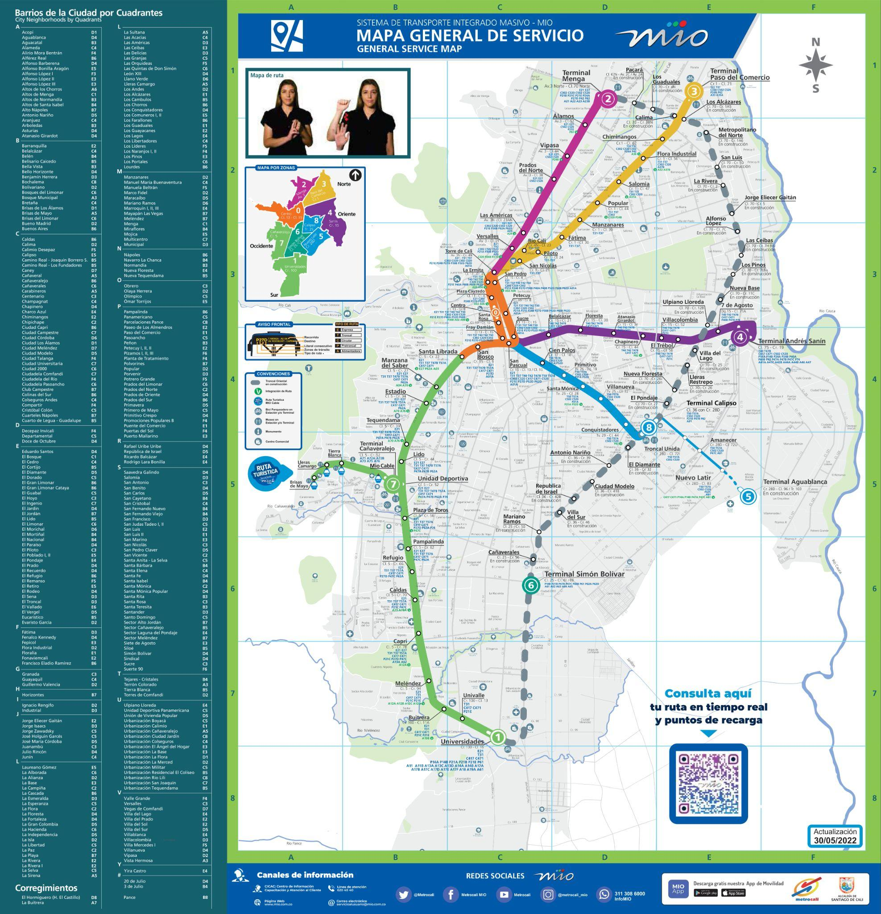

The person using the system will be able to see which route takes less time between the station where he takes the bus and the one he wants to reach and will be informed which route he can use. Also, if you want to know which routes pass through certain station you will be given a list of the routes that arrive at that station, that is, you will be named the edges that connect with that vertex.

1. **Evaluation and selection of the best solution**

The best option for improving MIO transport efficiency is to develop routing software or application that uses graphs, in particular Dijkstra's algorithm, to calculate the shortest and most efficient path between user-selected stations.

This approach has several significant advantages. First, the use of graphs makes it possible to accurately and efficiently represent the connections and relationships between MIO stations. Each station becomes a node in the graph, and connections between stations are represented as edges weighted by distance or travel time.

By applying Dijkstra's algorithm on this graph, the shortest path between the source station and the destination station can be found. The algorithm takes into account the weights of the edges and looks for the optimal route minimizing the distance or total travel time. This ensures that users can find the most relevant and fastest route for their journey on the MIO.

In addition, by offering an interface where users can enter the source station and destination station, the software or application can provide a customized and specific solution for each user. This allows users to quickly get the information they need to plan their trip, without having to navigate complicated maps or consult multiple sources of information.

In summary, the creation of a MIO routing software that uses graphs and the Dijkstra algorithm is the best option to achieve optimal efficiency in mass transport. It provides users with a customized solution to find the shortest and most efficient route between selected stations, improving the planning and travel experience in Cali's MIO system.

1. **Preparation of Reports and Specifications**

It is loaded to you via a csv file. The information of the routes (edges) and the stops (vertices) in order to visualize the organization of the graph. Then you will be passed the options to choose if you want to see a list with the routes related to a station or if you want to see the fastest route between two stations. It is considered that all stops have at least one assigned route since they are main trunk roads that feed the entire transport system of the city and that the routes have a connection between at least two stops.